Endorsor Verifier 2.0 Manual

Introduction: The Endorsor Verifier module of the endorsor enables you to authenticate digitally signed documents received from the brokers and the associated signature.
Steps for Installation of Endorsor Verifier

Double click on file. It shows the next screen given below.
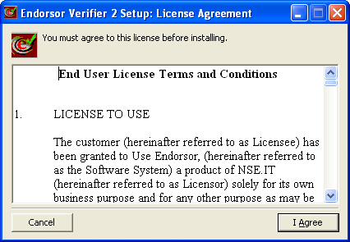
Click on ‘I Agree’ button

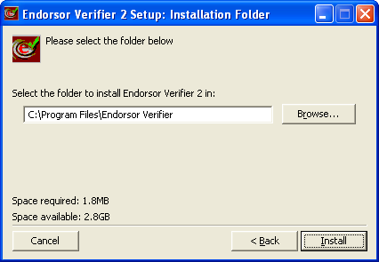

Click on ‘Install’ button. (If want to keep default position as given screenshot otherwise you may change the installation directory by clicking ‘Browse’ button.)

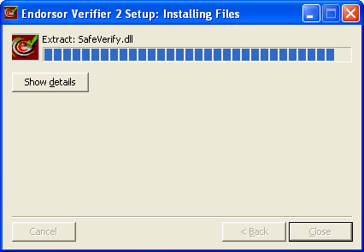

It will shows the installation progress.

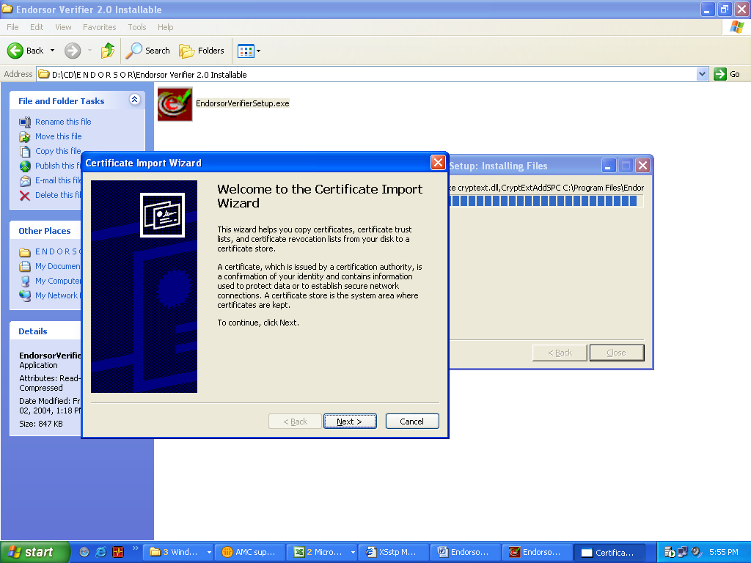
Now click on ‘Next’ button
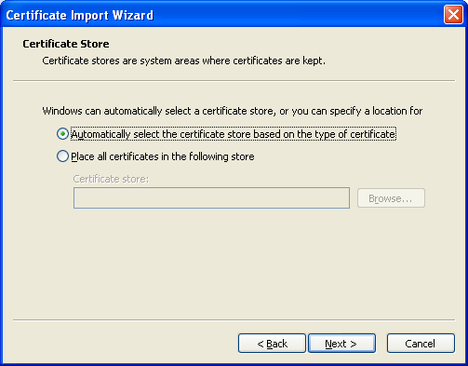

Keep default settings (do not change settings) and click on ‘Next’ button.

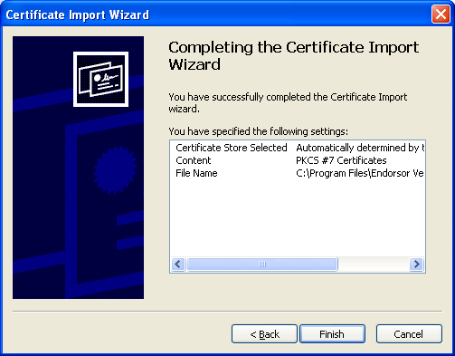

Now click on ‘Finish’ button. After this will give the ‘The Import was successful’ message box like below.

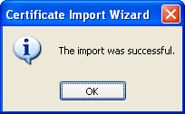

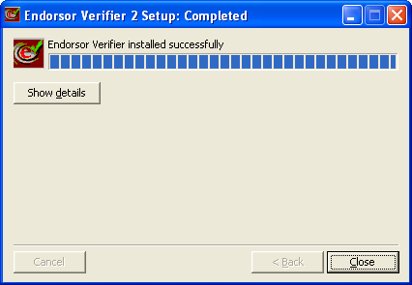

Now click on ‘Close’ button. Now Endorsor Verifier 2.0 installation is done successfully.

Root-chain certificate installation guide.
After installing Endorsor verifier 2.0 you may asked for installing a root-chain certificate. Here are the procedures to install a root-chain certificate.

This is a symbol of root-chain certificate → .

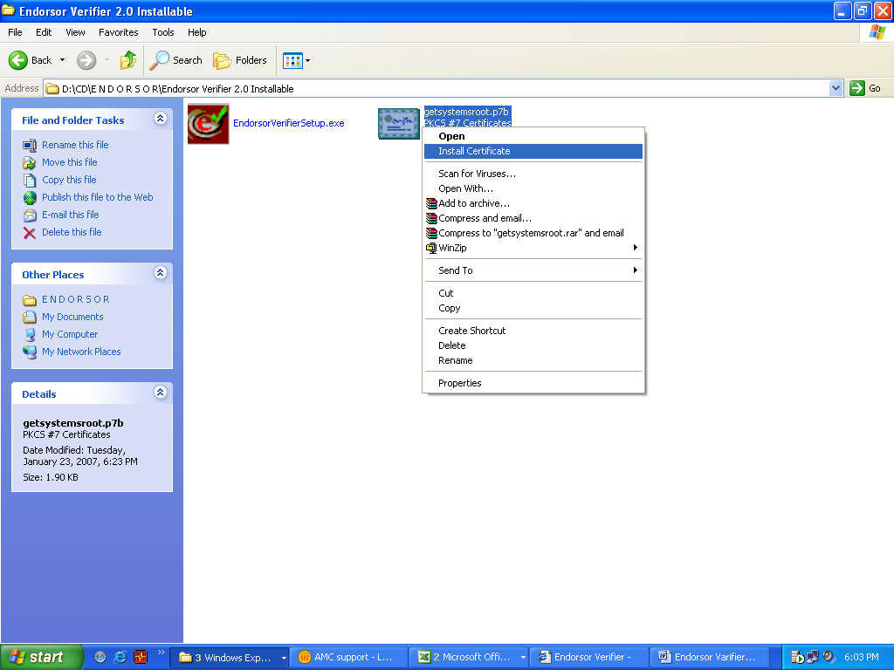

Right click with mouse at the root-chain certificate. Select ‘Install Certificate’

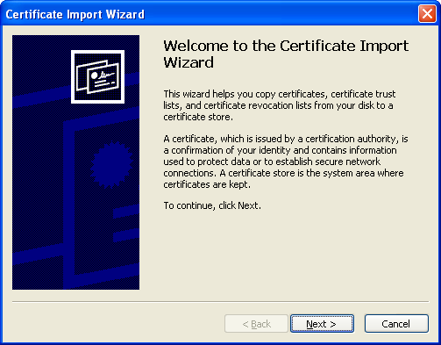

Click on ‘Next’ button.

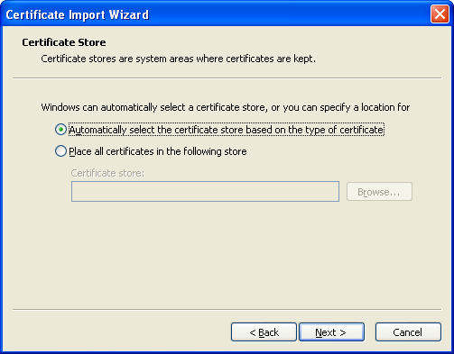

Just click on ‘Next’ button again (Don’t change the default option unless you are sure about it).

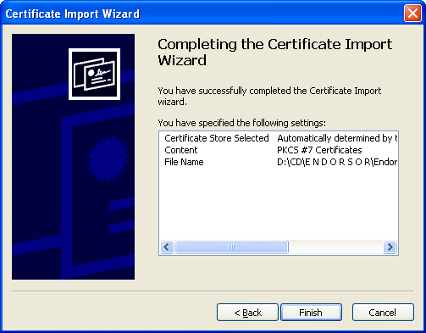

Click on ‘Finish’ button.

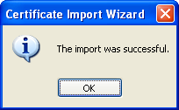

Now a message will like this will show to confirm successful import (installation) of root-chain certificate.

Now click onicon on desktop. It will start the endorsor 2.0 verifier application.

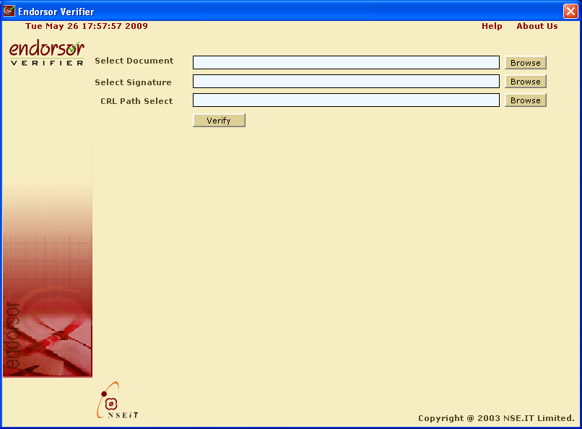

Click on first ‘Browse’ button on right side.

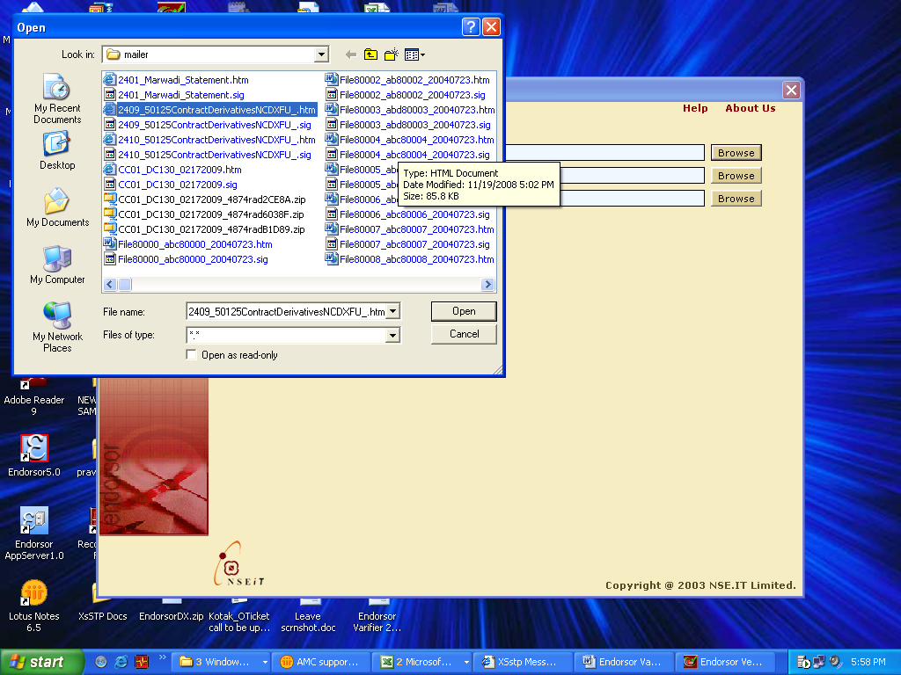

Select the contract note file you want to verify and click on ‘Open’ button.

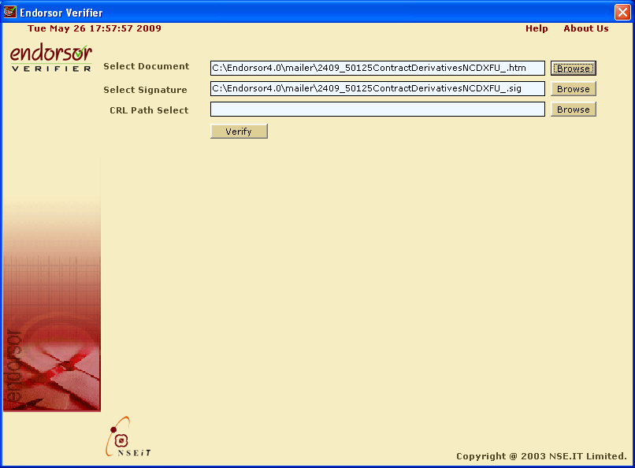

It will select the Signature file automatically. If the signature file not selected automatically then click on ‘Browse’ button and select the necessary signature file (with .sig extension). Click on ‘Verify’ button

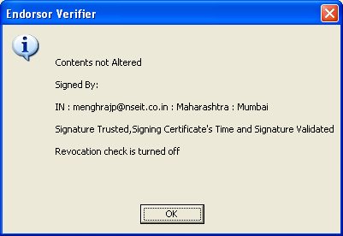

It will shows message like this screenshot and shows that the contents not altered. Otherwise it will shows like message below:

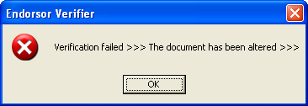

Note: Unsuccessful Verification
Verification is unsuccessful in three situations:
- The signature in the document does not match the selected signature.
- The signature is not trusted
- The certificate used to sign the document has been revoked.
If the selected signature does not match the signature in the signed document, an error message displayed.
If the signed document uses a revoked certificate, a screen is displayed.
If the signed document uses a revoked certificate, a screen is displayed.
Even though the verification is unsuccessful, you can still view the document.

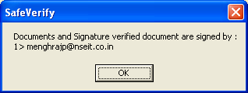
After successful verification of document with signature it will shows message like this with certificate email ID. Click ‘Ok’ button.

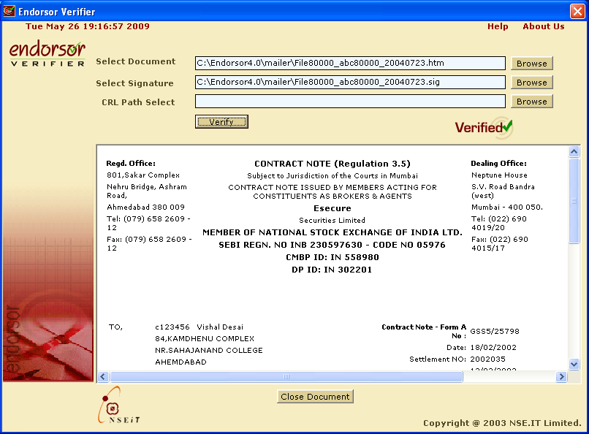

Now it will shows the Contract Note pre-view with a mark ‘Verified’. Now click on ‘Close Document’ to close the pre-view window. Document & signature verification done successfully.

